Jabber
Clearing the cache

Task | Descriptions
Sign-out Jabber
Then Exit Jabber Completely
Navigate to the following AppData Folder | Simply change text in red to your user-name then copy and paste into windows search   C:\Users\rgrey\AppData\Roaming\Cisco\Unified Communications
Delete Jabber folder* | 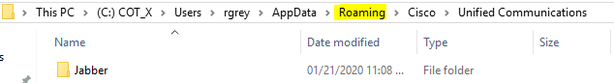
Navigate to the following AppData Folder | Simply change text in red to your user-name then copy and paste into windows search   C:\Users\rgrey\AppData\Local\Cisco\Unified Communications
Delete Jabber folder | 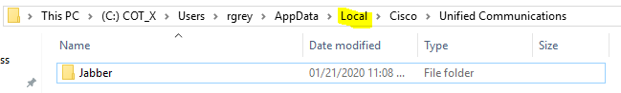
Launch and sign back into Jabber
Check voicemail | Verify voicemail connected and you can access

*Note: Jabber History will be lost

